How to Use YouTube Capture
- Download the free app “YouTube Capture” from the app store on your iPad.

- Open the app.

- Check your tuning.

- Have your partner press the red record button on the screen to begin recording.

- State the name of the piece and measure numbers you are playing.

- Turn on the metronome to the required speed.

- Play the excerpt with the metronome.

- Repeat the process with the 2nd and 3rd excerpts (all pieces should be played in one single video).

- Have your partner press the red record button to stop recording.

- Press the arrow in the top right of the screen to get to the “Upload to YouTube” screen.

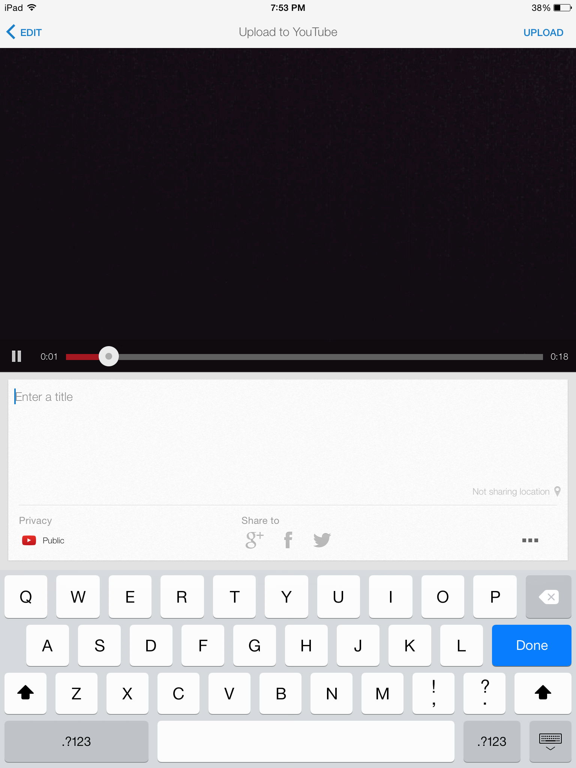
- Enter in a title in this format:
“First Last, SO: Playing Test #1”

- Underneath “Privacy” choose the setting
“Unlisted: Anyone with the link can view”

- Press “UPLOAD” in the top right
hand corner.

- On the “Select” screen, choose your
214 Student email address.

- If you don’t have one already, create a
YouTube channel that is linked to your email.

- Once your video has uploaded to your YouTube
channel, click on the video to show its information.

- Click on the link underneath the video.

- Choose “Email”.

- Send the email in this format:
- To: maura.brown@d214.org
- Subject: “First Last, SO: Playing Test #1”
- Body of Email: Link to your YouTube video
(ex. – https://www.youtube.com/watch?v=U8TcrMFFqJg)

